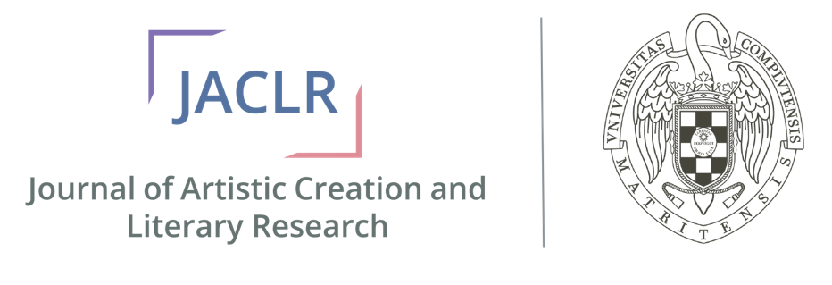

JACLR: Journal of Artistic Creation and Literary Research is a bi-annual, peer-reviewed, full-text, and open-access Graduate Student Journal of the Universidad Complutense Madrid that publishes interdisciplinary research on literary studies, critical theory, applied linguistics and semiotics, and educational issues. The journal also publishes original contributions in artistic creation in order to promote these works.
Volume X Issue 1/2 (June 2020)
Name Surname
“Title”
Recommended Citation

Surname, Name. "Title” JACLR: Journal of Artistic Creation and Literary Research X.X (201X):
<https://www.ucm.es/siim/journal-of-artistic-creation-and-literary-research>
©Universidad Complutense de Madrid, Spain
Abstract: 200 words aim of this academic paper is to analyse the conflict of identities, what is known as cultural

Keywords: six.

Name SURNAME
Paper Title

- Introduction
1. Section Title
2. Section Title
3. Conclusion

Works Cited

The part in red is not necessary in the case of ‘Creative works’.

Bioprofile of the author
Contact: < >

